INFORMATION MANAGEMENT
Exercise 6
1. List all employees on the basis of the salary they draw.
SELECT * FROM employee_data ORDER BY salary;
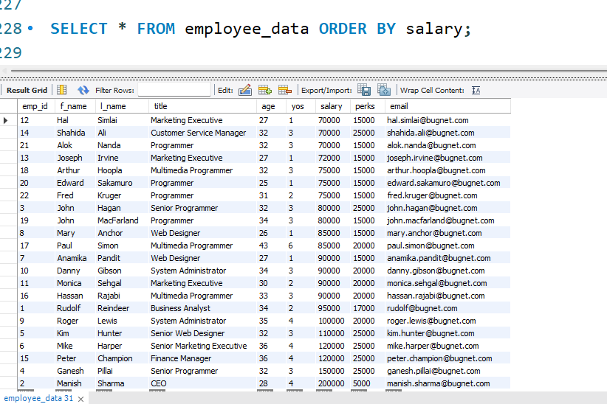
2. List all employees in descending order of their years of service.
SELECT * FROM employee_data ORDER BY yos DESC;
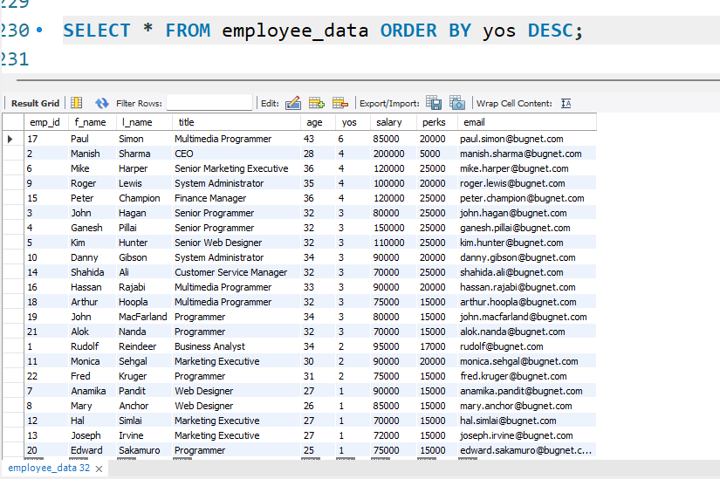
3. What does this statement display?
SELECT f_name, l_name FROM employee_data LIMIT 5;
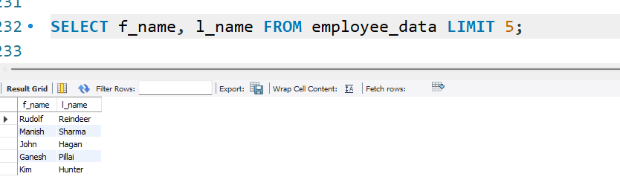

4. Display employees (last names followed by first names) who hold the title Programmer, Senior Programmer, or Web Designer and sort their last names alphabetically.
SELECT l_name, f_name FROM employee_data WHERE title IN ('Programmer', 'Senior Programmer', 'Web Designer') ORDER BY l_name;
